**https://rahulshettyacademy.com/gq/graphql**

**QUERY**

query($characterId : Int!, $episodeId : Int!)

{

character(characterId: $characterId)

{

name

gender

status

id

}

location(locationId: 984)

{

name

dimension

}

episode(episodeId: $episodeId)

{

name

air_date

episode

}

characters(filters:{name: "Abhishek"})

{

info

{

count

}

result

{

status

type

}

}

episodes(filters: {episode: "hulu"})

{

result

{

id

name

air_date

episode

}

}

}

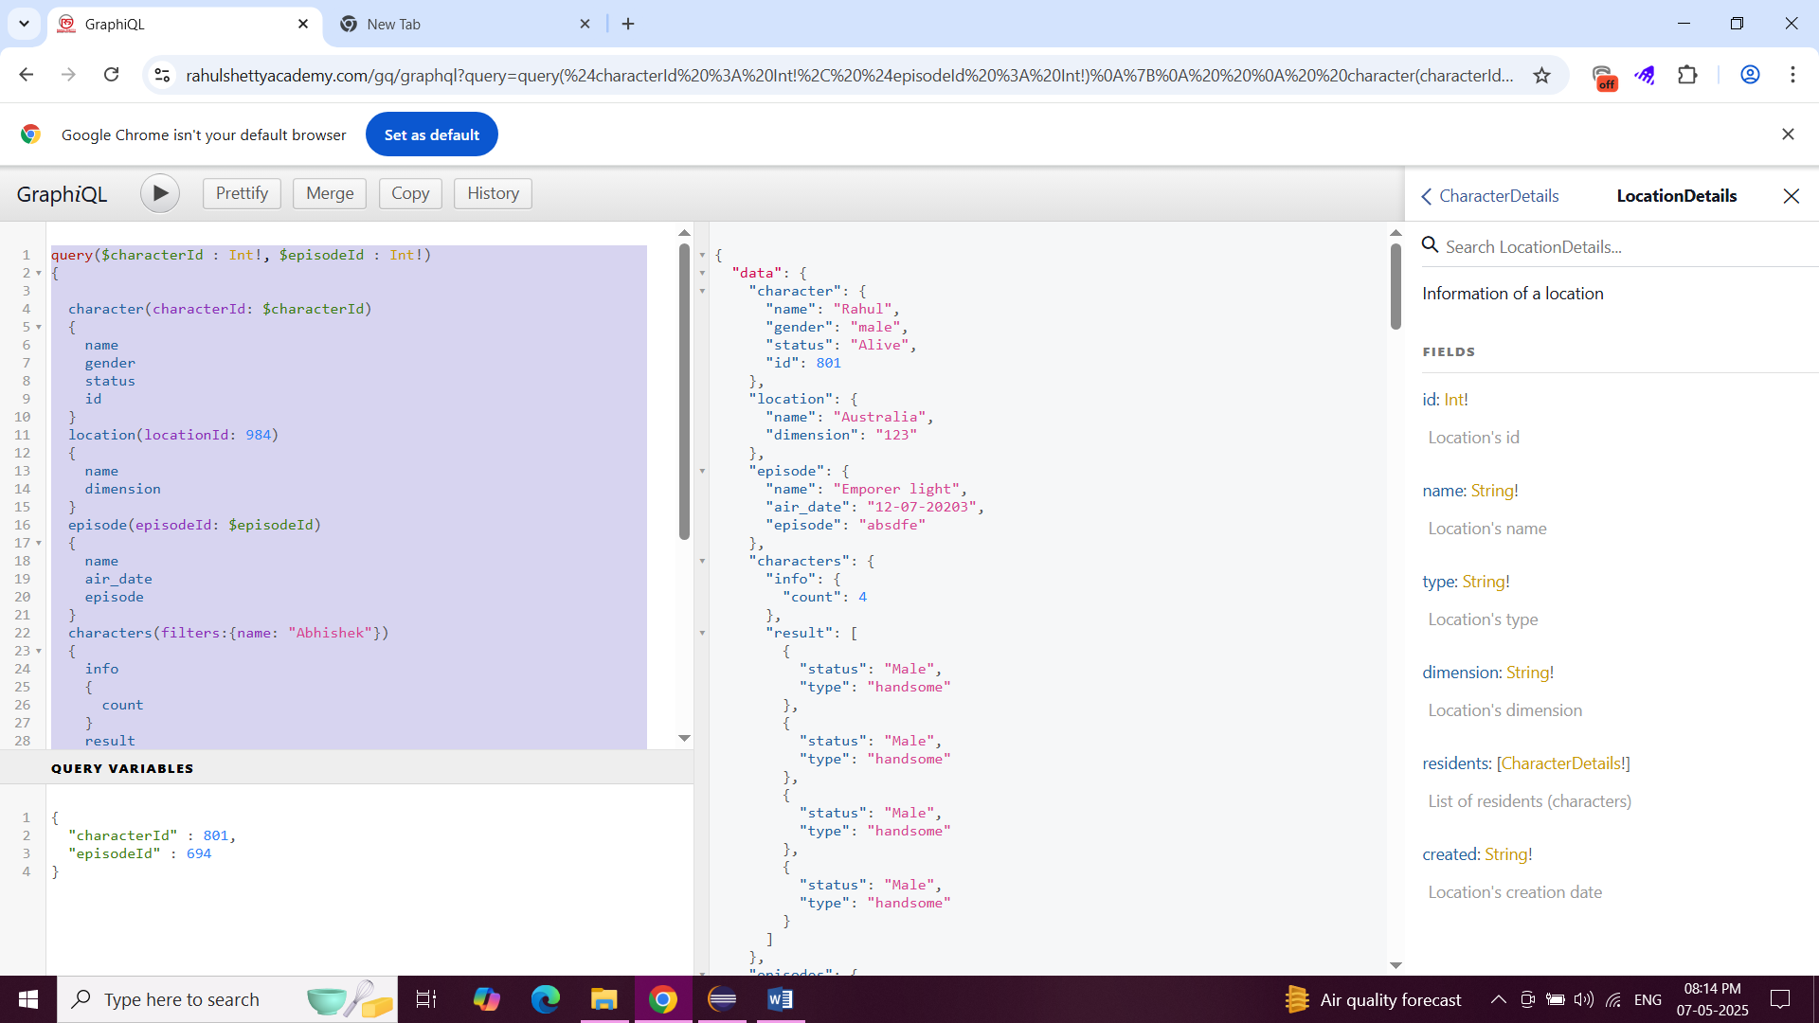

**Mutation**

mutation($locationName:String!, $characterName:String!, $episodeName:String!)

{

createLocation(location : {name : $locationName, type: "Central", dimension : "238"})

{

id

}

createCharacter(character : {name:$characterName,type:"Detective",status:"Alive",species:"Human",gender:"Male",image:".png",locationId:20849,originId:20849})

{

id

}

createEpisode(episode:{name:$episodeName,air_date:"2018",episode:"8"})

{

id

}

deleteLocations(locationIds:[20851,20850])

{

locationsDeleted

}

}

